SKILL PRACTICES TO USE WITH COMFORT KITS
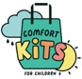
Skill #6: Get Moving!
What does this help? Improve your mood, sleep better, reduce discomfort, and have more energy.

What is it?
Ideas for fitness and relaxation activities -- most kids find them fun and helpful.

What items do you need?
Activities can be simple, like taking a walk, shadow boxing, dancing, or even doing chores! Animal poses may need a flat surface with a mat or just the floor.

How to do it?
- Animals move or pose in many ways. You can copy them and move into a position or stance. Then hold the pose. This can boost your energy.
- Let’s see what it’s like to imitate these animal moves (you might want to add sounds, too): Bear crawl, Crab walk, Gorilla walk, Bunny hop, Frog jump, Caterpillar crawl, Seal hobble, Duck walk, Flamingo pose.
- You imitate a snake (some call it Cobra Pose). Start by laying on your belly. Bring your hands flat to the ground under the shoulders. Use your back muscles and the core of your body, lift your upper body. Hold yourself like this and take a few breaths. Release your body from this position and breathe out. Pause. Do this pose again: take in a deep breath, press up again into the Cobra Pose, and hiss like a snake.
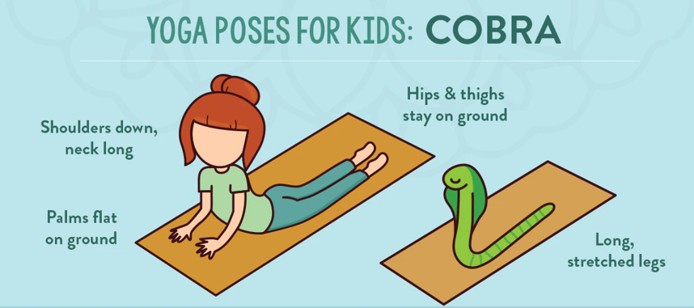

- Imitate a turtle. It is called, Half Tortoise or Child Pose. Start with your hands and knees comfortably on the ground, press your hips back toward the heels. Stretch out your arms in front of your head. Bring the palms together. Breathe deeply in and out for about 30 seconds. Release the position and start again.
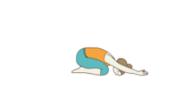
When to use Cobra Pose?
Whenever you feel you need a quick energy boost! You improve your energy level and release tension just by moving your body this way.

When to use Tortoise/Child Pose?
Whenever you want to calm yourself and re-charge your energy level! Some people believe that moving into this position gives you support, like a good night’s sleep!

