SKILL PRACTICES TO USE WITH COMFORT KITS
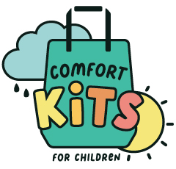
Skill 1: Feel Better - Breathe to Relax

What does this help? Worries, trouble sleeping, pain
What is it?
When you control your breathing, you control the body’s response. Athletes, singers, and even movie stars do this all the time!
What items do you need?
There are lots of tools and tips that can help you do this type of breathing: notice your lungs and chest as they move; place your hand on your belly-button as your tummy goes in and out; blow long, slow soap bubbles or blow on a pinwheel; rest a finger puppet or small stuffed animal on your belly and give it a ride to the sky; and find a comfortable place to rest. Of course, you can use this breathing skill without anything but yourself, too.
How to do it?
- Imagine you have a balloon in your belly.
- Let all your muscles be soft, loose, and comfortable.
- Breathe in slowly through your nose. Next, breathe out slowly through your mouth.
- Breathe out for longer than you breathed in, making it feel very slow and comfortable. Experiment and be curious to see how long you can pause and then let the air out.
- You can slow down the “out” breath by breathing out through a straw or by making an “s” sound as you blow out. Feel your belly get big, like a balloon blowing up, as you breathe in.
- If you like, you can place your hand or your favorite stuffed animal on your belly button and feel it move up and down with the in and out breaths (as you give it a “ride”).
- As you slowly let the air out and your belly gets flat, imagine you are breathing out any uncomfortable feelings or stress.
When to use it?
- As often as possible, at least 2 or 3 times every day.
- Do this before the discomfort or unpleasant moments start, during the discomfort or difficult time, and after it is all finished.
- Do this to help you at other times too -- while you are helping your family, waiting to go somewhere, playing with friends, going to bed at night, etc.
- Do this any time you are feeling nervous, stressed, or upset.

